University Exam Scheduling as a CSP
PEAS, Agent Type, CSP Formulation, Backtracking and Forward Checking
Problem: Schedule 5 exams – A (Artificial Intelligence), B (Database Systems), C (Computer Networks), D (Operating Systems), E (Software Engineering) – into 3 slots (Slot1, Slot2, Slot3) so that the conflicting pairs A–B, A–C, B–C, B–D, C–D, C–E, D–E never share a slot. Slots are abbreviated S1, S2, S3 in tables.

a) PEAS Description (10 marks)
PEAS element | Description
Performance measure | • Zero conflicts: no two conflicting courses share a slot (hard constraint)  • All 5 exams scheduled, each exactly once, using only Slot1–Slot3  • Fewer search steps / backtracks (computational efficiency)  • (Optional soft goals) balanced slot usage, fewer students with back-to-back exams
Environment | University exam timetabling: 5 courses (A–E), 3 slots (one per day), a conflict list of 7 pairs from shared student enrolments. Fully observable, deterministic, static, discrete, single-agent, sequential (episodic assignments build one timetable).
Actuators | Assign (or un-assign) a slot to a course; output/publish the timetable; report failure if no valid schedule exists.
Sensors | Course list, slot list, enrolment/conflict data (the 7 conflicting pairs), and the current partial timetable (which courses already hold which slots).

b) Type of Agent (10 marks)
Best suited: Goal-based agent.
Agent type | How it works | Suitability for exam scheduling
Simple reflex | Acts on the current percept only (condition–action rules) | Unsuitable: a slot choice depends on earlier choices, so it needs memory of the partial timetable and look-ahead.
Model-based reflex | Keeps internal state, but still acts through fixed rules | Insufficient: tracks the timetable but has no explicit goal and cannot search/backtrack.
Goal-based | Searches/plans for action sequences that reach an explicit goal state | BEST FIT: the goal (complete, conflict-free timetable) is clear and binary.
Utility-based | Maximises a utility function over goal states | Not required: all valid timetables are equally acceptable here; useful only if soft preferences were added.

Justification:
- The task has an explicit goal state: every course holds a slot and no conflicting pair shares one. The agent must find a sequence of assignments that reaches it.
- Decisions are interdependent. Choosing Slot1 for A removes Slot1 from B and C, so the agent needs a model of the partial timetable and must look ahead and backtrack when a branch fails – a reflex agent cannot do this.
- Success is binary (valid / not valid). All conflict-free timetables are equally good, so no utility function is needed. A utility-based agent would only be justified if soft preferences (e.g. balanced days, gaps between exams) were added.
- A goal-based agent whose goal test and search are structured as a CSP solver (backtracking + inference) matches this problem directly.

c) CSP Formulation and Constraint Graph (15 marks)

Variables, Domains
Variable | Course | Domain
A | Artificial Intelligence | {Slot1, Slot2, Slot3}
B | Database Systems | {Slot1, Slot2, Slot3}
C | Computer Networks | {Slot1, Slot2, Slot3}
D | Operating Systems | {Slot1, Slot2, Slot3}
E | Software Engineering | {Slot1, Slot2, Slot3}

Constraints (binary, inequality)
Conflicting pair | Constraint
A–B | A ≠ B
A–C | A ≠ C
B–C | B ≠ C
B–D | B ≠ D
C–D | C ≠ D
C–E | C ≠ E
D–E | D ≠ E

In compact form: for every conflicting pair (X, Y), slot(X) ≠ slot(Y). Courses with no listed conflict (e.g. A–D, A–E, B–E) may share a slot.

Constraint graph
Vertices: {A, B, C, D, E}
Edges: {(A,B), (A,C), (B,C), (B,D), (C,D), (C,E), (D,E)} – 7 edges
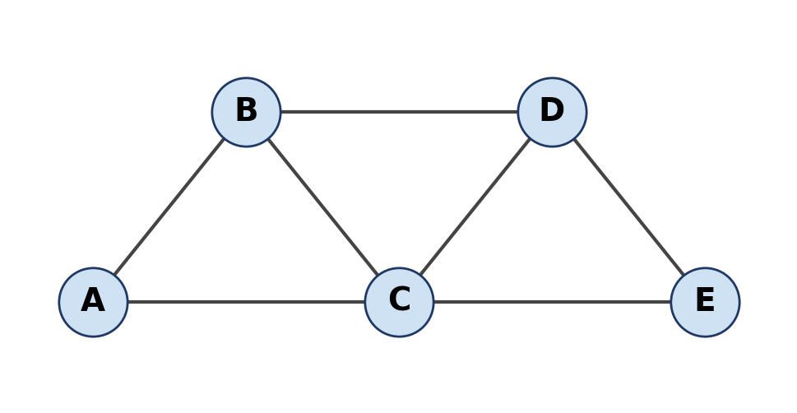
Vertex | Neighbours | Degree
A | B, C | 2
B | A, C, D | 3
C | A, B, D, E | 4
D | B, C, E | 3
E | C, D | 2

The graph consists of three triangles (A-B-C, B-C-D, C-D-E), so at least 3 colours (slots) are needed, and 3 suffice. C has the highest degree (4).

d) Plain Backtracking Search (25 marks)
Variable order: A → B → C → D → E. Value order: Slot1 → Slot2 → Slot3. A value is checked against already-assigned neighbours only (no look-ahead). Each value tried counts as one assignment attempt.
Step | Attempt | Result | Reason | Partial assignment
1 | A=Slot1 | OK | Consistent; assigned | A=S1
2 | B=Slot1 | Fail | Conflicts with A=Slot1 | A=S1
3 | B=Slot2 | OK | Consistent; assigned | A=S1, B=S2
4 | C=Slot1 | Fail | Conflicts with A=Slot1 | A=S1, B=S2
5 | C=Slot2 | Fail | Conflicts with B=Slot2 | A=S1, B=S2
6 | C=Slot3 | OK | Consistent; assigned | A=S1, B=S2, C=S3
7 | D=Slot1 | OK | Consistent; assigned | A=S1, B=S2, C=S3, D=S1
8 | E=Slot1 | Fail | Conflicts with D=Slot1 | A=S1, B=S2, C=S3, D=S1
9 | E=Slot2 | OK | Consistent; assigned | A=S1, B=S2, C=S3, D=S1, E=S2

Summary: 9 assignment attempts (5 successful, 4 failed), 0 backtracks. No variable ran out of values, so no consistent assignment had to be undone.
Final valid timetable: A = Slot1, B = Slot2, C = Slot3, D = Slot1, E = Slot2.
Check: A≠B (1≠2), A≠C (1≠3), B≠C (2≠3), B≠D (2≠1), C≠D (3≠1), C≠E (3≠2), D≠E (1≠2) – all satisfied. Exam days: Slot1 = AI and Operating Systems; Slot2 = Database Systems and Software Engineering; Slot3 = Computer Networks.

e) Backtracking with Forward Checking (20 marks)
Same variable and value order. After each assignment X = v, v is removed from the domain of every unassigned neighbour of X. If any domain becomes empty, the assignment is rejected immediately (wipe-out).
Step | Assign | Result | Values pruned | Domains of unassigned variables after step
0 | (start) | — | — | A:{S1,S2,S3} B:{S1,S2,S3} C:{S1,S2,S3} D:{S1,S2,S3} E:{S1,S2,S3}
1 | A=Slot1 | OK | Pruned B-Slot1, C-Slot1 | B:{S2,S3} C:{S2,S3} D:{S1,S2,S3} E:{S1,S2,S3}
2 | B=Slot2 | OK | Pruned C-Slot2, D-Slot2 | C:{S3} D:{S1,S3} E:{S1,S2,S3}
3 | C=Slot3 | OK | Pruned D-Slot3, E-Slot3 | D:{S1} E:{S1,S2}
4 | D=Slot1 | OK | Pruned E-Slot1 | E:{S2}
5 | E=Slot2 | OK | No pruning | (no unassigned variables left)

Walk-through:
- A = S1: removes S1 from B and C → B {S2,S3}, C {S2,S3}.
- B = S2: removes S2 from C and D → C {S3}, D {S1,S3}. (A is already assigned.)
- C = S3: removes S3 from D and E → D {S1}, E {S1,S2}.
- D = S1: removes S1 from E → E {S2}.
- E = S2: the only value left is consistent; all variables assigned.
Summary: 5 assignment attempts, 0 failures, 0 backtracks, 7 value prunings. The domains of C, D and E became singletons, so no wrong value was ever tried.
Final valid timetable: A = Slot1, B = Slot2, C = Slot3, D = Slot1, E = Slot2 (identical to part d).

f) Comparison (20 marks)
Measure | Plain backtracking | Backtracking + forward checking
Assignment attempts (values tried) | 9 | 5
– successful assignments | 5 | 5
– failed attempts (conflict found) | 4 (B=S1, C=S1, C=S2, E=S1) | 0 (those values were already pruned)
Backtracks (undo of a consistent assignment) | 0 | 0
Domain wipe-outs detected | — | 0
Values pruned by look-ahead | — | 7 (B1, C1, C2, D2, D3, E3, E1)
Final timetable | A=S1, B=S2, C=S3, D=S1, E=S2 | A=S1, B=S2, C=S3, D=S1, E=S2

Efficiency
- Attempts: forward checking needs 5 attempts versus 9 – about 44% fewer. It makes exactly one attempt per variable, which is the minimum possible for 5 variables.
- Backtracks: both runs have 0 backtracks here. The value and variable order happen to lead straight to a solution, so the advantage of forward checking shows up only in failed attempts, not in backtracks.
- Overhead: forward checking does extra work after every assignment (updating neighbour domains: 7 removals in total). This is cheap compared with the 4 wasted attempts it avoids, and the saving grows on larger problems.

Why forward checking reduces search effort
- It propagates each assignment to the unassigned neighbours immediately, so conflicting values are removed before they are ever tried. Plain backtracking discovers each conflict only when it reaches that value (B=S1, C=S1, C=S2, E=S1).
- It detects dead ends early. If a neighbour's domain becomes empty, the current assignment is rejected at once, instead of exploring a doomed subtree until it fails deeper down. That does not occur in this instance but is the main source of savings in harder ones.
- It exposes forced moves: C, D and E each reached a single remaining value, so the rest of the search was deterministic.
- In the worst case both methods remain exponential (up to 3^5 = 243 complete assignments), but forward checking prunes whole branches and is never worse in attempts than plain backtracking with the same orderings. Adding MRV/degree ordering or arc consistency would improve it further.
Conclusion: both methods give the same valid timetable (A=Slot1, B=Slot2, C=Slot3, D=Slot1, E=Slot2). Forward checking reaches it with fewer attempts and no wasted conflict checks, so it is more efficient. It is also unique up to renaming of slots: 3! = 6 valid timetables exist, because A, B, C must all differ, which forces D = A's slot and E = B's slot.

